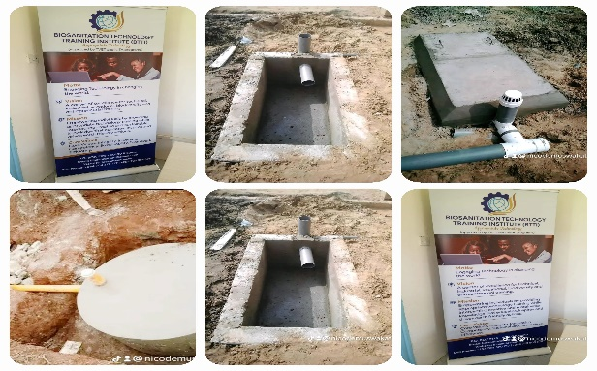

**P.O.BOX 40100-7178, KISUMU**

**Email*: biosanitationi@gmail.com***

**Website: biosantech.ac.ke**

**Cell-phone: +254-704-370-717/ +254-723-803-678**

**Approved TVET & NITA Programs**

|  |  |  |
| --- | --- | --- |
| **ARTISAN /SHORT COURSES** | **CERTIFICATE COURSES** | **DIPLOMA COURSES** |
| Bio sanitation Technology | Certificate in Information, communication Technology (ICT) | Diploma in Home Care Nursing (HCN) |
| Motor Vehicle mechanics | Certificate in Fashion & Design | Diploma in Community Health |
| Welding & Fabrication | Certificate in Tourism & Tour Guiding Technology | Diploma in Social Work & Community Development |
| Motorcycle mechanics | Certificate in Home Care Nursing (HCN) | Diploma in Food & Beverage Technology |
| Mobile phone maintenance & repair | Certificate in Community Health | Diploma in Counselling & Psychology |
| Solar Technology | Certificate in Social Work & Community Development | Diploma in business Management |
| Photojournalism & Photography Technology | Certificate in Business Management | Diploma in Health Records |
| Electrical Installation | Certificate in Project Management | Diploma in Information, communication Technology (ICT) |
| Masonry (with specialization in Biosanitation) | Certificate in Food & Beverage Technology | Fashion & Design Technology |
| Plumbing Technology (Specialization in Biosanitation) | Certificate in Computer proficiency | Diploma in Animal health |
| Food & Beverage Technology | Certificate in Marine Transport & Logistics | Diploma in agro business |
| Tailoring & Dress Making | Certificate in Artificial Intelligence (AI) & Robotics | Diploma in procurement |
| Security Guarding & Safety Training Technology | Certificate in Animal Health | Diploma in sales and marketing |
| Hare dressing & Beauty therapy | Certificate in Boat Making Technology | Diploma in hospitality management |
| Bread Making level 1 & 2 |  |  |

NB: All Artisan courses -**15,000/=** per term (5 terms)

For short Artisan courses-**25,000/=** three (3) months (for those with experience/skill)

Certificate courses- **15,000/=** per term (3 terms)

Diploma courses**- 20,000/=** per term (6 terms)

**INTAKES: January, May & September**

**ALL FEES ARE PAYABLE AT SCHOOL ACCOUNT**: **SBM BANK,**

**ACCOUNT NAME: BIOSANITATION TECHNOLOGY TRAINING INSTITUTE**

**ACCOUNT NO. 0152416939001 PAYBILL. 552800.**